brookhaven country day camp

We Miss
You
Only 274
Days Till
Summer
Hurry
Back

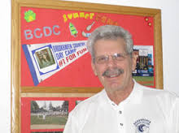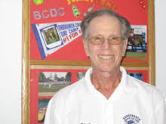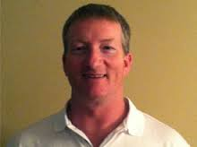
IT’S OCTOBER 1ST. DO YOU KNOW WHERE YOUR CHILD WILL BE THIS SUMMER?
DON’T FORGET! REGISTER FOR SUMMER CAMP 2019
PLANNING HAS BEGUN FOR 2019 AND WE WANT YOU TO BE A PART OF THE NEW AND EXCITING ACTIVITIES
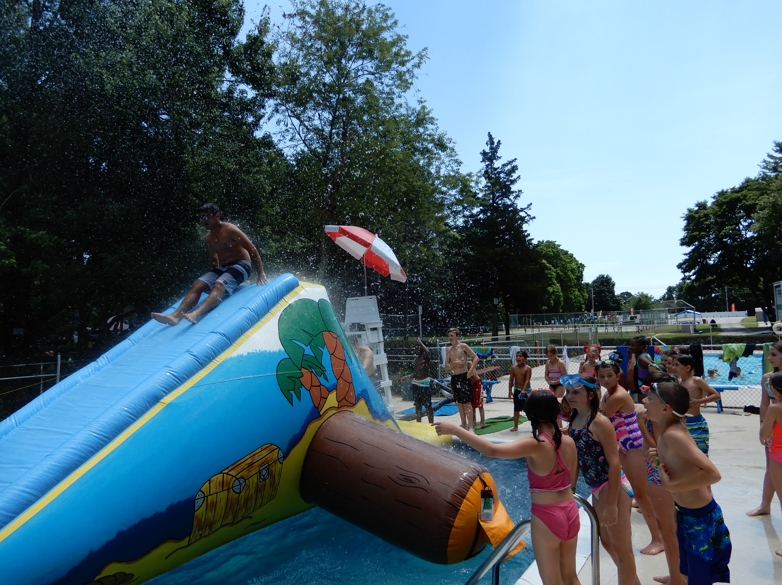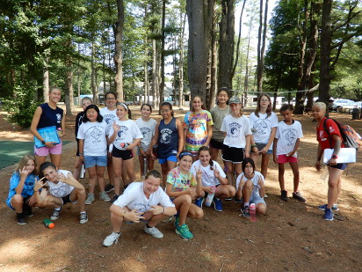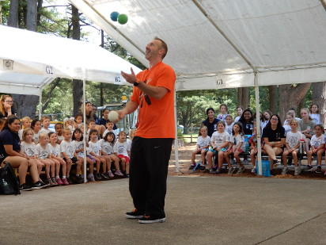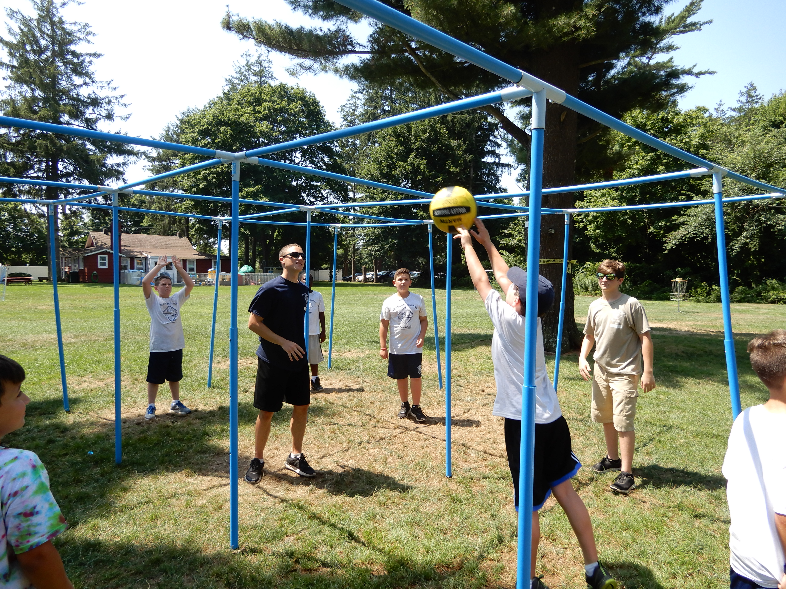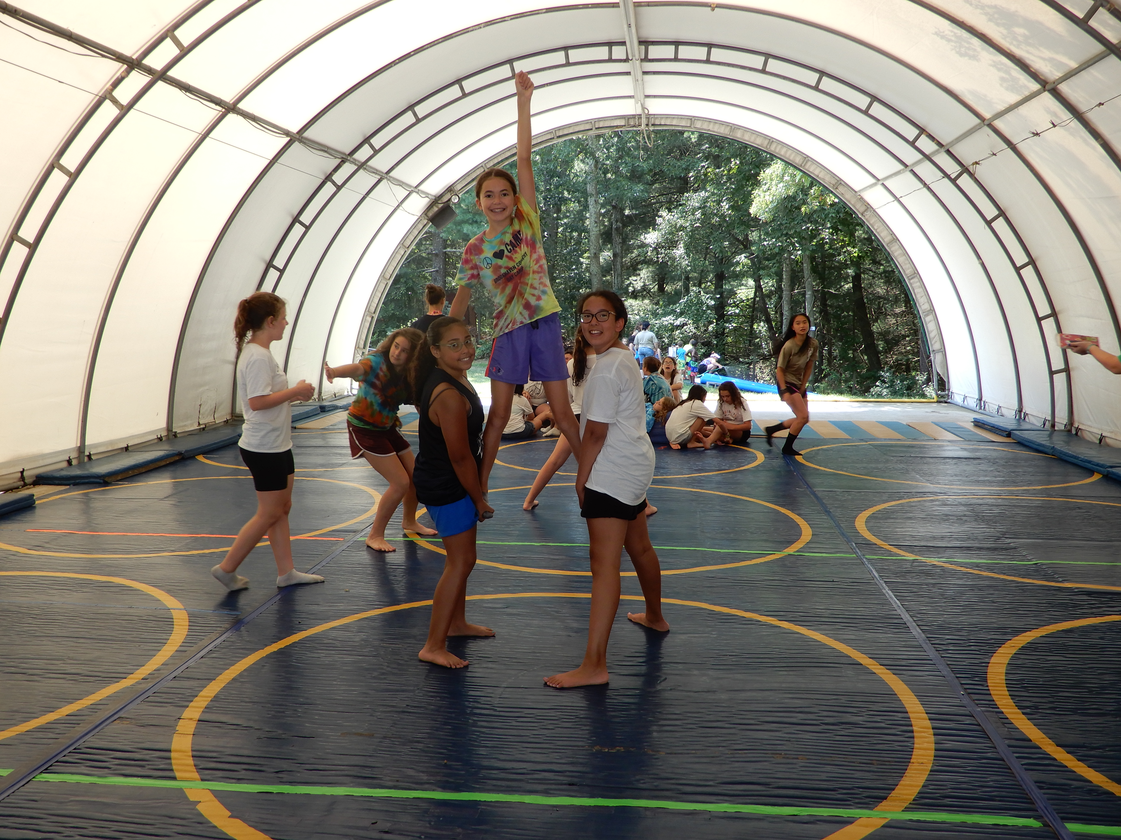

WE WISH EVERYONE A SUCCESSFUL SCHOOL YEAR

ALL STRAIGHT A’s
AND THEN:
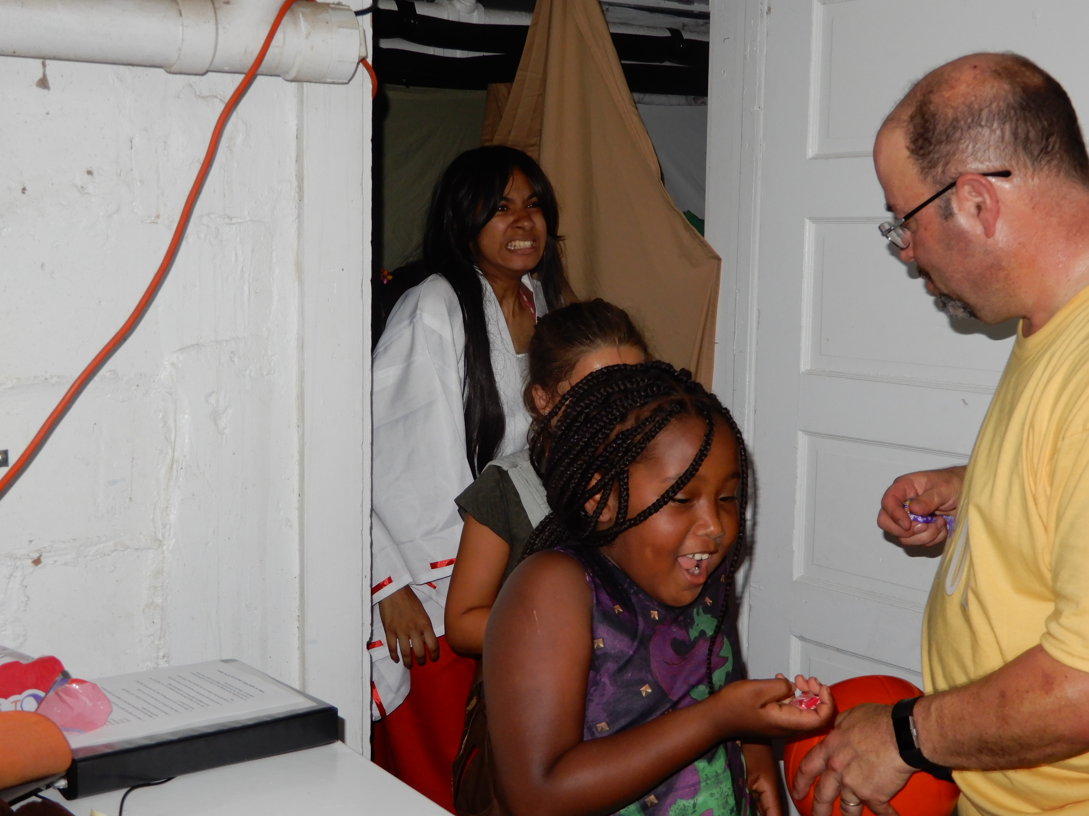
HALLOWEEN DAY – THE REAL ONE … “JUST LIKE AT CAMP”

OCTOBER BIRTHDAYS
10/1 Zoe Fyfe, Xavier Thompson 10/2 Derek Aiello, Julianna Magliulo, Gavin Katz 10/3 David Martinez, Chloe Somerlad, Alexa Laudadio, Briella Komosinski, Lexi Robinson 10/4 Kaden Burdge, Rayna Bruno, Jake Morreale, Rachel Fowler, Philip Tancora 10/5 George Agagnina 10/6 Sophia Brocco, Taty Morace 10/7 Mia Buonanotte, Susan Cutrone, Jack Walsh, Anthony Asquino, Cameron Saunders, Monika Arce 10/8 Brandon Makowski, Prescott Weeks, Mark Ward, Joseph Laudadio, Alexa Ferro 10/9 Bianca Butta 10/10 Janine Lenoble, Sophia Svedberg 10/11 Kaylee Graham, Erica Silver 10/12 Jemma Gessner, Lars King, Nolan Borders 10/14 Kaitlyn Badilla, Benjamin Moore, Aniyah Thomas 10/15 Kaelyn Schmidt 10/16 Dominick Jalayer, Jacob Miller, Francesca Barlowe 10/17 Michael LaMotto 10/18 Brian O’Sullivan 10/19 Ethan Eubanks, Liliana Moran, Brady Brownrigg, Ethan Eubanks, Jocelyn Salavarria 10/20 Andrew Denaro 10/22 Julian Fox, Annique Meara 10/23 Jack Fenech 10/24 Joel Estrada 10/26 Kyle Jones, Celia Caputo, Olivia Guglielmo, Brianna Valente, Calvin Corkery 10/27 Gia Curcio, Morgan Kelly, Sabrina Calazans 10/28 Daniel Matthews, Alexander Gennaro, Maximus Gennaro 10/29 Kailin Fitzgerald, Jacob Lincoln, Emily Carter-Morano 10/30 Steven Abramowitz, Ryan Panker, Lindsay llg 10/31 Matthew Baumann, Jacob Coda

