BROOKHAVEN COUNTRY DAY CAMP
SPECIAL EVENTS CALENDAR 2018

June-July 2018

 | MONDAY | TUESDAY | WEDNESDAY | THURSDAY | FRIDAY
W  E  E  K  1 | 25 LET THE  MEMORIES BEGIN    SUMMER 2018 | 26 JR. CAMP  PONY RIDES    TRIP FOR JR.TEENS  PRE-TEENS B6 & G6 | 27  INTERNATIONAL  DAY   | 28  PAJAMA BOTTOMS DAY    TRIP FOR JR.TEENS | 29  CRAZY HAIR  DAY    TRIP FOR JR.TEENS  AND PRE-TEENS
W  E  E  K  2 | 2  JR. CAMP  SWIM GAMES    TRIP FOR PRE-TEENS  B6 & G6 | 3 HAPPY BIRTHDAY  BROOKHAVEN COUNTRY DAY CAMP    EXCELLENCE IN CAMPING  50 YEARS AT A TIME | 4  Have a Blast!  INDEPENDENCE  DAY    CAMP CLOSED | 5 SR. CAMP GA GA  TOURNAMENT  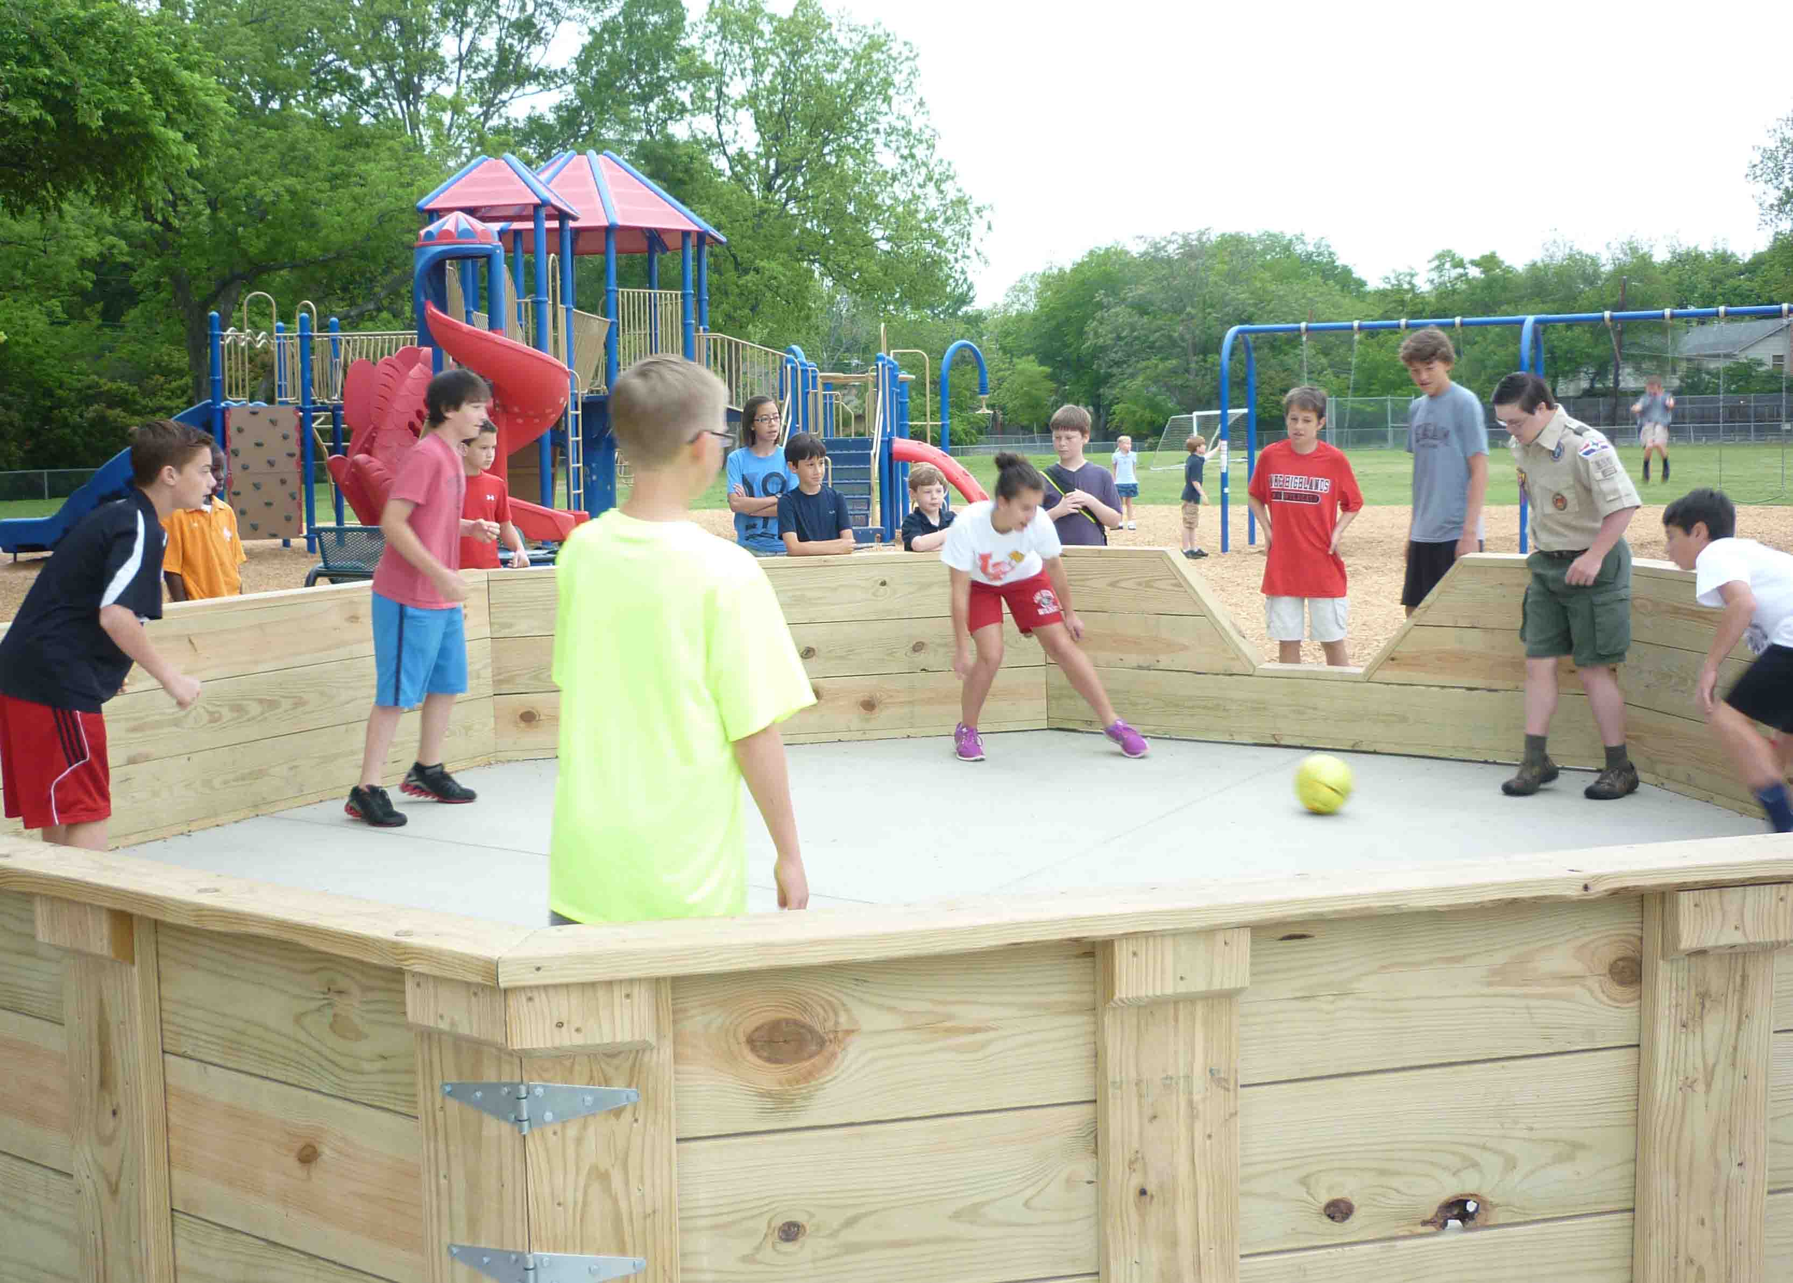  TRIP FOR CITS  AND JR.TEENS  LAKE COMPOUNCE  AMUSEMENT PARK  TRIP FOR PRE TEENS | 6    Dance Fever  X GAMES  TRIP FOR JR.TEENS
W  E  E  K  3 | 9  LATE NITE  B4 & G4  TYE-DYE WEEK   | 10  LATE NITE  B5 & G5  HALLOWEEN DAY    TRIP FOR JR.TEENS  AND PRE-TEENS | 11  LATE NITE  B6 & G6  PICTURE DAY!    TRIP FOR B6 & G6 | 12  LATE NITE  JTs & PRE TEENS  JR. CAMP GA GA TOURNAMENT  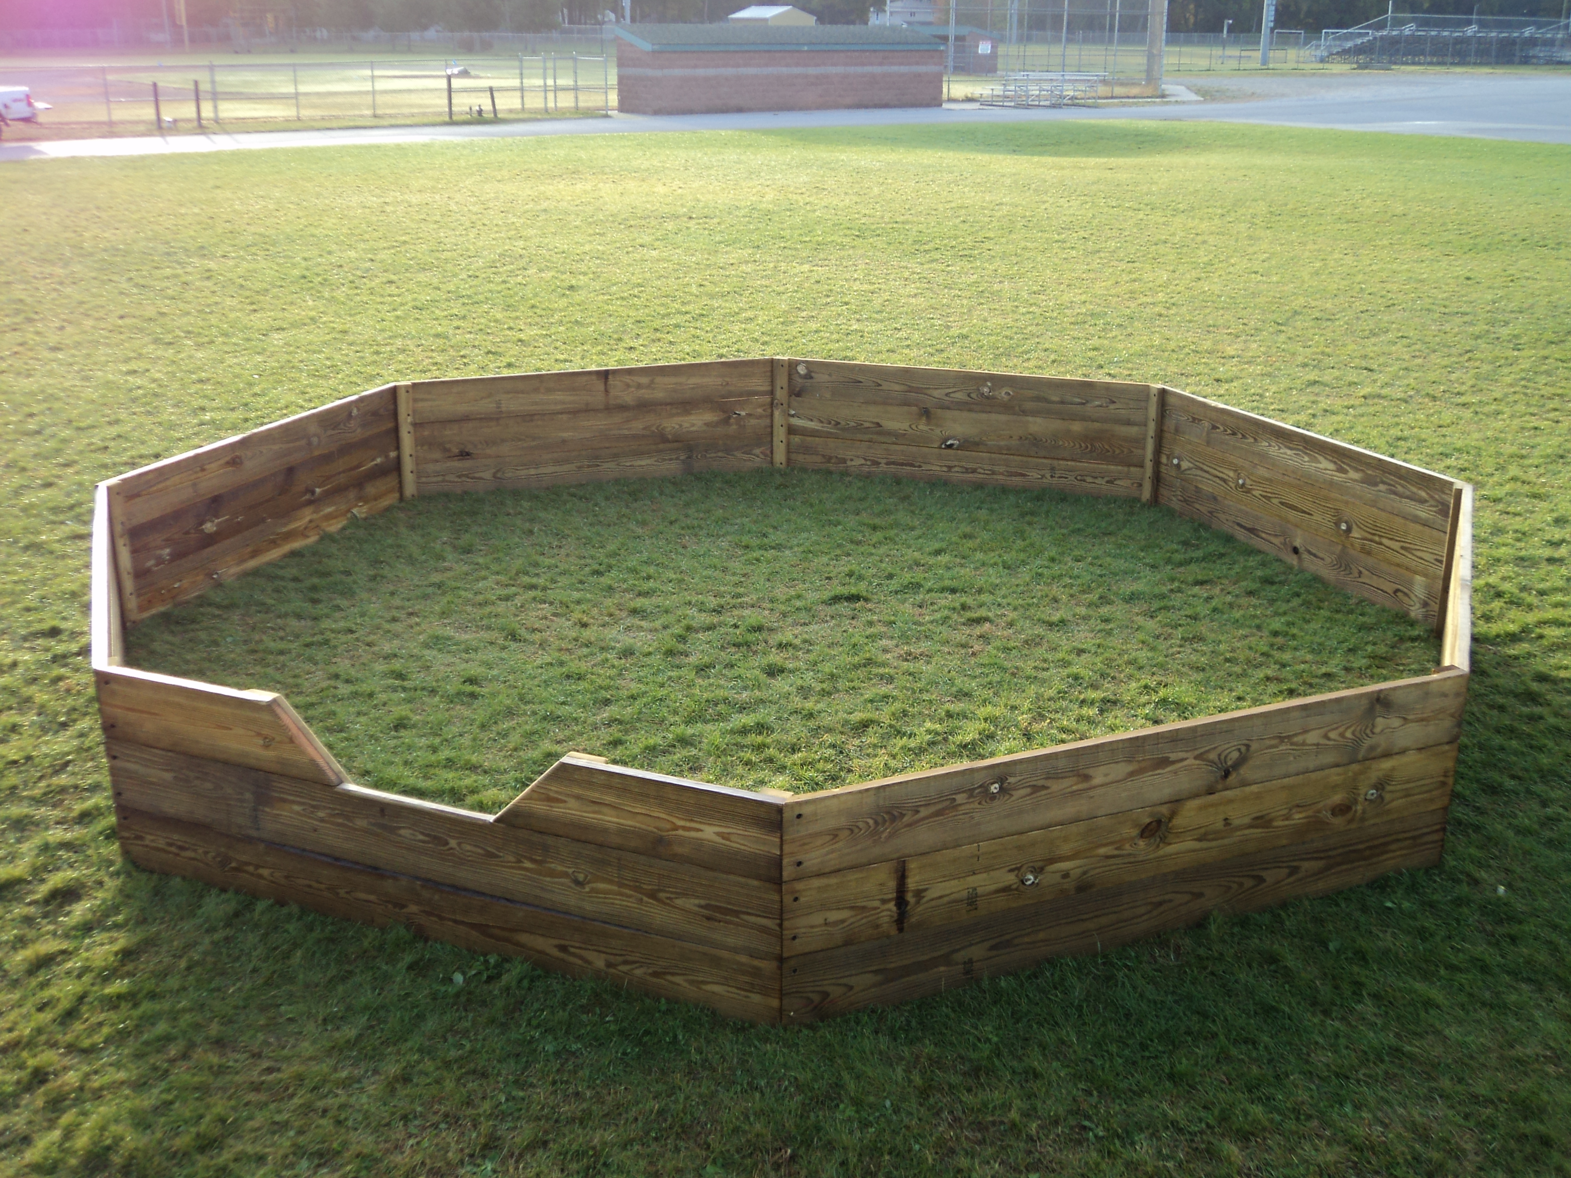  PICTURE DAY CONTINUES  TRIP FOR JR. TEENS & PRE-TEENS | 13  AMUSEMENT  DAY  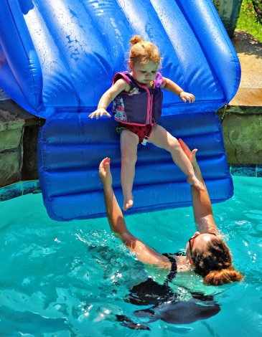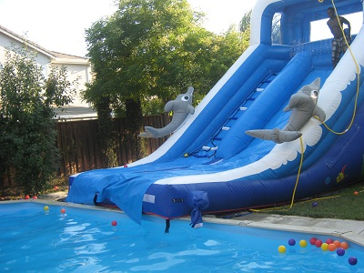  WEAR YOUR TYE-DYE  SHIRT DAY  TRIP FOR JR.TEENS
W  E  E  K  4 | 16    WACKY RELAYS  FOR JR. CAMP  “JESTER JIM”  TRIP FOR JR.TEENS  & PRE-TEENS, | 17    DANCE SHOW  1:15 PM  PARENTS WELCOME TO ATTEND | 18    DRAMA CLUB SHOW  1:15 PM  PARENTS WELCOME TO ATTEND  LONG ISLAND DUCKS  TRIP FOR JR.TEENS PRE-TEENS, B6 G6 | 19 GYMNASTICS  SHOW 1:15 PM    PARENTS WELCOME TO ATTEND  TRIP FOR CITs AND JR. TEENS  GREAT ADVENTURE | 20  “COME AND GET IT”    TEXAS BBQ
(All events are subject to change)

BROOKHAVEN COUNTRY DAY CAMP
SPECIAL EVENTS CALENDAR 2018

July-August 2018

 | MONDAY | TUESDAY | WEDNESDAY | THURSDAY | FRIDAY
W  E  E  K  5 | 23    AT BROOKHAVEN    SR. CAMP GA GA TOURNAMENT  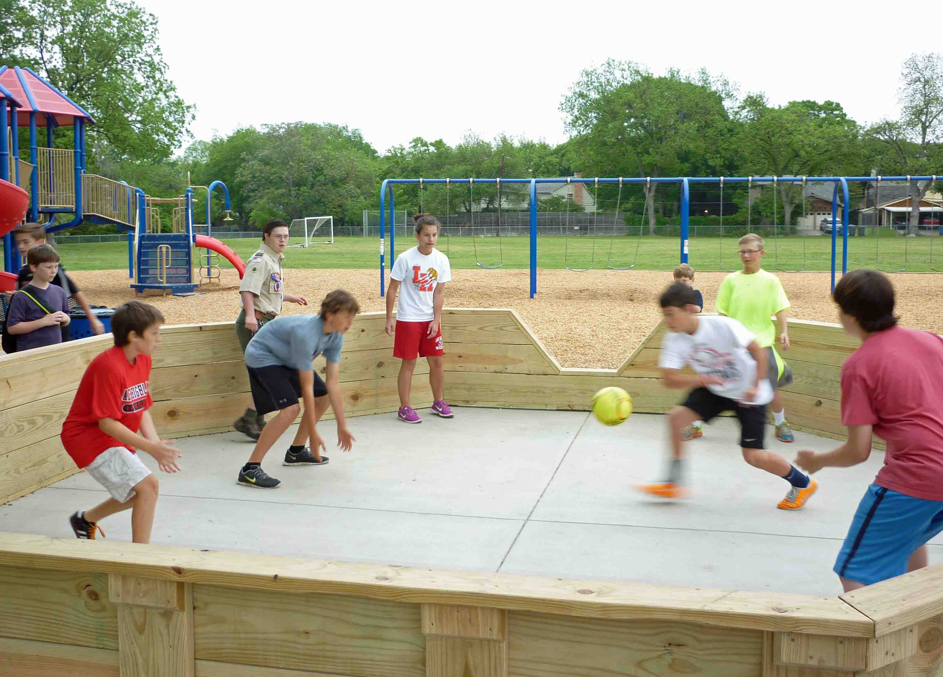 | 24  FAVORITE  TEAM DAY        &  SPECIAL MAGIC SHOW | 25  JR. CAMP  OLYMPICS  GAMES AND FUN    TRIP FOR JR.TEENS, PRE-TEENS, B6 G6 | 26  JR. CAMP OLYMPICS    MORE GAMES & FUN  SPLISH SPLASH  FULL DAY TRIP FOR CITS, JR. TEENS & PRE TEENS | 27  SUPER HERO DAY    TRIP FOR JR.TEENS
W  E  E  K  6 | 30 TREASURE  HUNT DAY    TRIP FOR JR.TEENS  PRE-TEENS | 31 APACHE RELAY BEGINS   | 1  APACHE RELAY  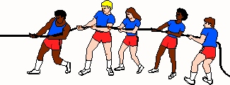 | 2 Apache Relay    Banners, Cheers & PLAQUES | 3    BIRTHDAY  BALL  TRIP FOR JR.TEENS,  PRE-TEENS & B6 G6
W  E  E  K  7 | 6    SENIOR & JUNIOR  CAMP WATER  GAMES  TRIP FOR JR.TEENS  B6 & G6 | 7     X GAMES  TRIP FOR JR. TEENS & PRE TEENS | 8  CARNIVAL &  PARENT VISITING DAY  1:00 – 2:30   | 9 JR. CAMP  PONY RIDES  SR. CAMP GA GA TOURNAMENT #2 | 10  CRAZY SOCK DAY    CAPTREE FISHING TRIP FOR JR.TEENS AND PRE-TEENS
W  E  E  K  8 | 13  ICE CREAM SUNDAE DAY    TRIP FOR JR.TEENS  AND PRE-TEENS | 14  DANCE SHOW  1:15 PM  PARENTS WELCOME TO ATTEND | 15  GYMNASTICS SHOW 1:15 PM  PARENTS WELCOME TO ATTEND  TRIP FOR CITs & JTs  BROADWAY SHOW  SCHOOL OF ROCK | 16  DRAMA CLUB SHOW  1:15 PM  PARENTS WELCOME TO ATTEND | 17  LAST DAY  AWARDS & GOODBYES  TEXAS BBQ  SEE YOU  NEXT SUMMER  TRIP FOR JR.TEENS,  PRE-TEENS, B6 & G6
(All events are subject to change)

